**June 10 - 13, 2024 ® La Crosse Center ® La Crosse, WI**

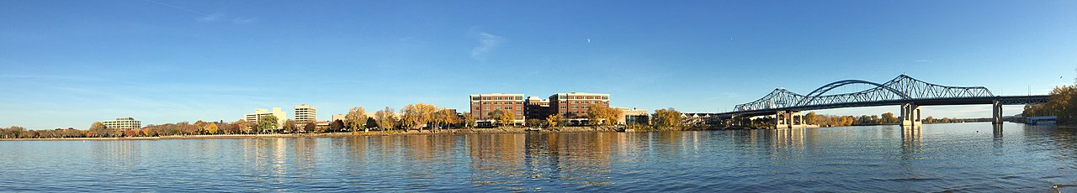

**NATIONAL FARM BUSINESS MANAGEMENT CONFERENCE**

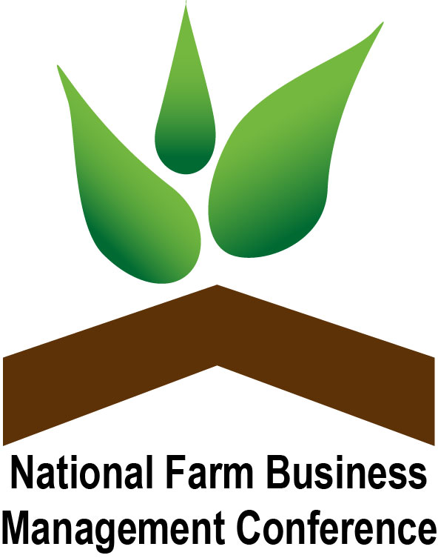

**Post-Conference Tour Schedule**

Thursday, June 13, 12:15 – 4:15 PM ⬥ All Tours depart from La Crosse Center, 2nd Street South Entrance

(updated 5/28/24)

**Tour A – La Crosse, WI**

[**Kwik Trip Dairy Plant**](https://www.kwiktrip.com/our-story) – (16 yrs. minimum age, 30 person max.) – Kwik Trip Way, La Crosse, WI

We’re a family-owned company based in La Crosse, WI and home to more than 35,000 co-workers. If you’ve been in Wisconsin, Minnesota or Iowa recently, there’s a good chance we’ve seen you at one of our 800+ stores.

Mission - “To serve our customers and community more effectively than anyone else by treating our customers, co-workers, and suppliers as we, personally, would like to be treated and to make a difference in someone’s life.”

Our Dairy - Every gallon of milk is bottled within 24 hours of reaching our dairy.

[**Cargill**](https://www.cargillag.com/) - 816 Bainbridge Street, La Crosse3 (Bump caps required). 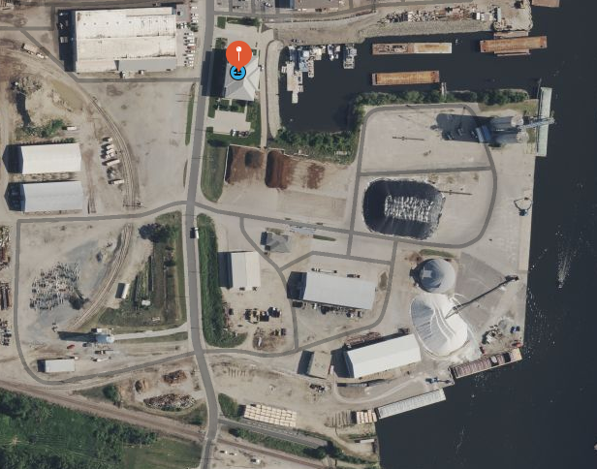

Tour of office, weighing & testing, storage facilities, loading barges, history, importance of barge use & traffic. They also bring in other materials from other parts of the world.



**Tour B** **– West Salem** ([link to paramotor video tour](https://youtu.be/CFpvjKuPB0k)) (20-30 people)

[**Jolivette Family Farms**](https://www.jolivettefamilyfarm.com/)- Wisconsin 16, West Salem, WI 54669

Since 1970, we have been *the* favorite destination for fresh, farm-grown fruit and vegetables for everyone throughout the 7 Rivers Region. The 500-acre Jolivette family farm yields a bountiful harvest of strawberries, sweet corn, and so much more. See videos at link above.

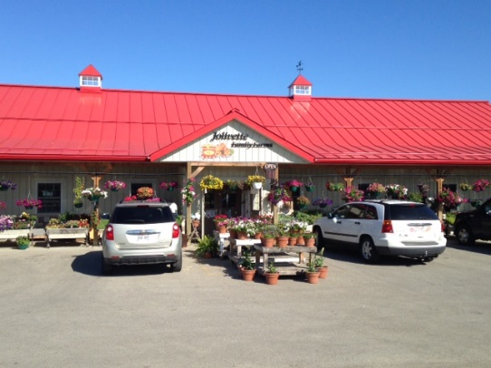

[**La Crosse Seed**](https://lacrosseseed.com/) - 2541 Commerce Street, La Crosse, WI 54603

Now part of [DLFPickSeed](https://www.dlfpickseed.com/usa). Learn about the history and services of La Crosse Seed and how it evolved into what it is today. You will also develop a better understanding of the grass, forage and lesser-known seed industry.

**Tour C – Cashton** (longer tour time for travel)

[**Organic Valley**](https://www.organicvalley.coop/)- 509 Organic Dr, Cashton

[**Cashton Farm Supply**](http://www.cfspecial.com/) – CFS Egg Processing facility – 105 Webster St., Westby, WI 54667

Cashton Farm Supply was established in 1984 and is focused on organic feed manufacturing and distribution. In addition, CFS also has organic custom pullet raising, poultry equipment sales and organic seed sales. Cashton Farm Supply, Ltd is certified as an Organic Feed Mill and has committed our business to the organic industry. We have become the leader in the organic industry in the state of Wisconsin. In the spring of 1987, we imported our first organic corn from Kansas to be used in organic dairy feed. We have earned a great reputation within the organic community and have been recognized as leaders in the organic poultry business.

**If time allows:**

[**Pasture Pride Cheese**](https://www.pasturepridecheese.com/) or [**Westby Cooperative Creamery Store**](https://www.westbycreamery.com/shop-online/)

Pasture Pride Cheese is located in Wisconsin in the heart of Amish Country. We craft our cheese with milk from local Amish dairies that is delivered to the factory in chilled milk cans, the old-fashioned way. We produce many varieties of cheese, including Pasture Pride Cheddars, Monterey Jack, Pepper Jack, Muenster, Colby and Co-Jack. In addition, Pasture Pride Cheese is home of “Juusto™” Cheese. This is a Finnish baked cheese manufactured in our factory in Wisconsin. Savor the buttery flavor. Juusto™ has been judged “Best of Show” in numerous cheese competitions.

**Tour Timetables***(times within tours are approximate)*

**Tour A**

|  |  |
| --- | --- |
| Time | Host: Lynn Hoffmann |
| 12:30 PM | Depart La Crosse Center |
| 12:45 PM | Arrive at Kwik Trip |
| 1:00 – 2:15 PM | Tour |
| 2:15 PM | Depart Kwik Trip |
| 2:30 PM | Arrive at Cargill |
| 2:30 – 3:30 PM | Tour |
| 3:45 PM | Arrive at La Crosse Center |

**Tour B**

|  |  |
| --- | --- |
| Time | Host: Brad Sirianni |
| 12:30 PM | Depart La Crosse Center |
| 12:50 PM | Arrive at Jolivette |
| 1:00 – 2:00 PM | Tour |
| 2:15 PM | Depart Depart Jolivette |
| 2:30 PM | Arrive at La Crosse Seed |
| 2:30 – 3:30 PM | Tour |
| 3:45 PM | Arrive at La Crosse Center |

**Tour C**

|  |  |
| --- | --- |
| Time | Host: Donna Gate |
| 12:15 PM | Depart La Crosse Center |
| 1:00 PM | Arrive at Organic Valley |
| 1:00 – 2:00 PM | Tour (split into at least 2 groups) |
| 2:15 PM | Depart Organic Valley |
| 2:30 PM | Arrive at CFS Egg Processing (may encounter road construction) |
| 2:30 – 3:30 PM | Tour |
| 4:15 PM | Arrive at La Crosse Center |

**Maps of Tour Stop Routes**

**Tour A Route:**

**Tour B Route:**

**Tour C Route:**

